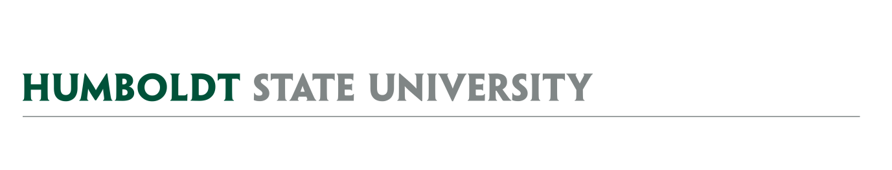
AGENDA
Facilities Management
University Space & Facilities Advisory Committee

MEETING LOCATION: SBS_405
MEETING TIME: 1:00-2:00pm, Friday, February 22, 2019

- February 8, 2019 Meeting Notes
  - Approve meeting minutes

- Vacated Space Reallocation Request Process
  - Recommendation for action (or not) and associated timeline

FUTURE AGENDA ITEMS
- Building Space Reports – SH, NR, FR
- Potential HSU Lactation Accommodation Policy
- Facilities Management Cost Recovery Policy
- IAPB – Review proposed process and discuss role of USFAC within that framework
- Major Capital Outlay Plan 20/21
- Private Use Reporting & Research Space Tracking
- Formalization of our Mural approval process and guidelines

ATTACHMENTS & LINKS
- February 8, 2019 Minutes
- Draft Vacated Space RFP (RFP University Space… docx)
- Link to Draft Space Request Webform
- Draft Rubric for scoring RFP responses (Vacated Space Rubric.xlsx)
- Floorplans (VacatedSpaceFloorPlans.pdf) of spaces for reallocation highlighted

REMINDER- Next USFAC meeting is March 8, 2019, 1:00-2:30PM, SBS_405.

