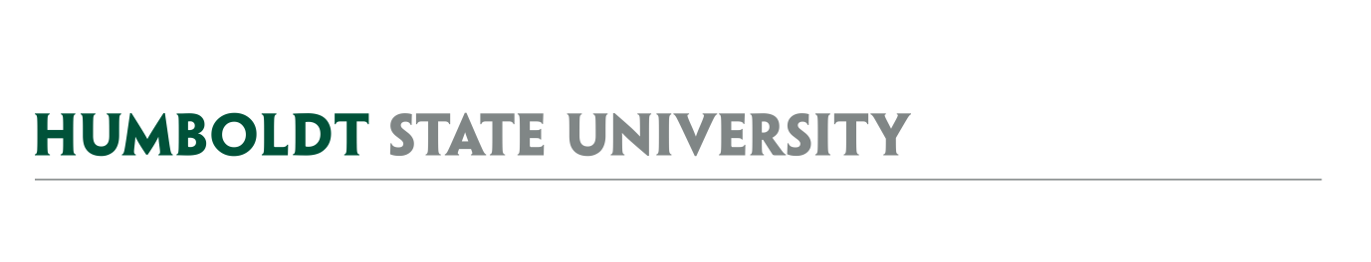
AGENDA
Facilities Management
University Space & Facilities Advisory Committee

MEETING LOCATION: SBS_405
MEETING TIME: 1:00-2:30pm, Friday, March 8, 2019

- February 8 and February 22, 2019 Meeting Notes
  - Approve meeting minutes - Review main points from Vacated Space discussion (2/22/19)

- AY1819 USFAC Details
  - Student reps

- USFAC Subcommittees
  - Landscape Working Group
  - Naming Committee
  - Sports Facilities Scheduling Committee
  - Facilities Use Group
  - Vacated Space Working Group - Discussed below in 4.b.

- Space Management Issues
  - Math Space Swap – Space-type change proposed (added after agenda was circulated)
    - Self-Instruction Lab (BSS_316A) to Lecturer offices
    - Research Space (BSS_312 – which was being used as Lecturer offices) to Self-Instruction Lab for Math and Computer Science
  - Vacated Space Working Group
    - Request for proposals update
    - Athletics is being asked to organize tours
  - Lactation accommodations (see attached AE Bulletin from state)
    - University Senate involvement – Policy
  - Example of a Building Space Report
    - Future FacilitiesLink automated Report – update on discussions with MetaBIM
  - Classroom furniture issues
    - Classroom furniture project for summer 2019
    - Utilization Calculations (see attached Draft Building Space Report)
    - Funding plan for furniture refresh in different space types – USFAC role?
    - Disappearing classroom furniture – USFAC role?

- Physical Master Plan – No Update

- Capital Outlay Plan – Update from Mike

FUTURE AGENDA ITEMS
- IAPB – Review proposed process and discuss role of USFAC within that framework
- Private Use Reporting & Research Space Tracking
- Formalization of our Mural approval process and guidelines

ATTACHMENTS & LINKS
- Minutes from 2/8/19 & 2/22/19 USFAC Meetings
- Link to formal RFP Vacated Space announcement from 3/1/19
- State of California "lactation accommodations" - see page 7 (AE Bulletin 2019-01...pdf)
- Draft SH Building Report with notes (pdf)

REMINDER- Next USFAC meeting is planned for 4/5/19, and it’s planned to be a full USFAC meeting, 1:00-2:30, SBS_405. The focused group meeting was canceled due to spring break.

