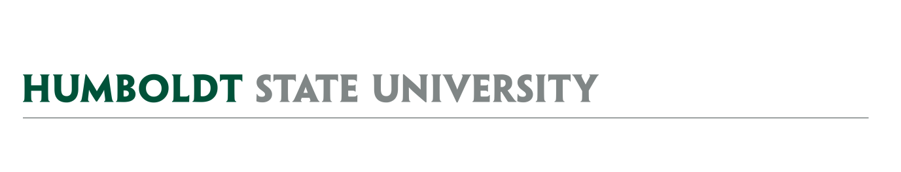
AGENDA
Facilities Management
University Space & Facilities Advisory Committee

MEETING LOCATION: SBS_405
MEETING TIME: 1:00-2:30pm, Friday, May 3, 2019

- April 5 & April 19 Meeting Notes (update on Vacated Space process)

- AY1819 USFAC Details
  - Meetings over summer - scheduled

- USFAC Subcommittees
  - Landscape Working Group
  - Naming Committee
  - Facilities Use Subcommittee
  - Vacated Space Working Group

- Capital Outlay Plan – Update from Mike

- Space Management Issues
  - Vacated Space
    - Requests for FWH & WAGH & Hilltop Marketplace – Process
    - Requests for other locations that were not included in Football space
      - Request 15 – SPF request in SBS
      - Request 22 – Lactation Station near Library Circle
  - Campus Key Policy – Building Coordinator update
  - Building Space Reports – NR & FR
    - NR_108 space type update – Action needed.
    - ITS office spaces in NR – No action expected at this time
  - SFDB Update
    - Private Use Reporting
    - Custodial Square Footage
    - SFDB Difference report
      - Classroom capacity updates.
  - Classroom furniture issues
    - Classroom furniture project for summer 2019
      - Related topic - Allocation of “Lecture space”.
        - BSS_162 Native American Forum allocation.
        - Other lecture spaces that are allocated but maybe shouldn’t be?
    - Utilization Calculations (see attached Draft Building Space Report)
    - Funding plan for furniture refresh in different space types – USFAC role?
    - Disappearing classroom furniture – USFAC role?

- Physical Master Plan – Update from Mike

FUTURE AGENDA ITEMS
- IAPB – Review proposed process and discuss role of USFAC within that framework

ATTACHMENTS & LINKS
- Minutes from 4/5/19 & 4/19/19 USFAC Meetings (docx)
- Building Report (pdf)
- Campus Key Policy Draft (link)

REMINDER- Next USFAC meeting is planned for 5/24/19, 1:00-2:30, SBS_405.

