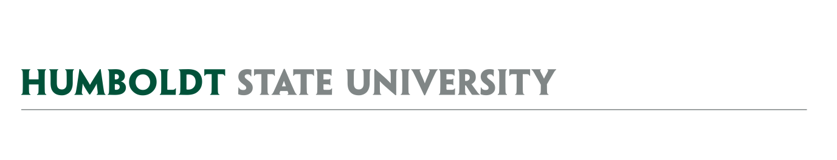
AGENDA
Facilities Management
University Space & Facilities Advisory Committee

MEETING LOCATION: SBS_405
MEETING TIME: 1:00-2:30pm, Friday, August 23, 2019
SPECIAL LOCATION: FGYM_148 (new classroom)

- July 19 Meeting Notes

- AY1920 USFAC Details
  - New Membership
    - Welcome Sherie Gordon – President’s Office Appointee
  - Shared Drive - USFAC

- Special Topic - Building Liaison (Time Certain 1:00-1:10)
  - Guest Kim Comet
  - Quick summary of duties planned for short term and long-term for this position. Relate to Cris’s building-level Emergency management teams.

- Special Topic - Integrated Assessment, Planning, and Budgeting – (Time Certain 1:10-1:25)
  - Guests Melinda Haynes-Swank & Travis Williams will present quick overview of the IAPB process framework, the proposed campus roll-out timeline, and the AY1920 pilot summary.

- Special Topic – Lactation Spaces (Time Certain 1:30-1:50)
  - Guests Katie Koscielak, Rob Keever, and others
  - Discuss lactation spaces planned for Fall 2019 and beyond
  - Public comment opportunity

- Special Topic – Murals on Campus (Time Certain 2:00-2:15)
  - Guest - Jason Meriwether
  - Discuss mural process in the past, and relate to plans for the future (see related documents showing previous mural processes)

- USFAC Subcommittees
  - Landscape Working Group
  - Naming Committee
  - Facilities Use Subcommittee
  - Vacated Space Working Group

- Space Management Issues (if time remains)
  - Vacated Space
    - New requests
    - Announcements
  - Summary of campus space moves
  - Capacity Changes
    - TA_018 (formerly TA_017) going from 36 capacity (about 15.6 sqft/station) to 28 capacity (about 20 sqft/station).
    - LIB_121 Self Instruction Computer Lab in Library going from capacity of 26 to 35

FUTURE AGENDA ITEMS
- Campus Key Policy – Next Focused meeting
- Facilities Management Cost Recovery Policy

ATTACHMENTS & LINKS
- Minutes from 7/19/19 USFAC Meeting (docx – attached and link)
- Building Liaison Portal Announcements from 8/15/19 (link)
- Integrated Assessment, Planning & Budget Initiative (link)
- Documents related to Lactation Station Requests (Letter from Katie Koscielak - link)
- Documents related to the murals from 2015/16 (EO-276 link)
- Draft new HSU Key Policy (link) & 1996 HSU Key policy (link) for next time.

REMINDER – Next focused USFAC meeting is planned for 09/13/19, 1:00-2:00pm, SBS_405. Next full USFAC meeting is 9/27/19, 1:00-2:30pm, SBS_405.

