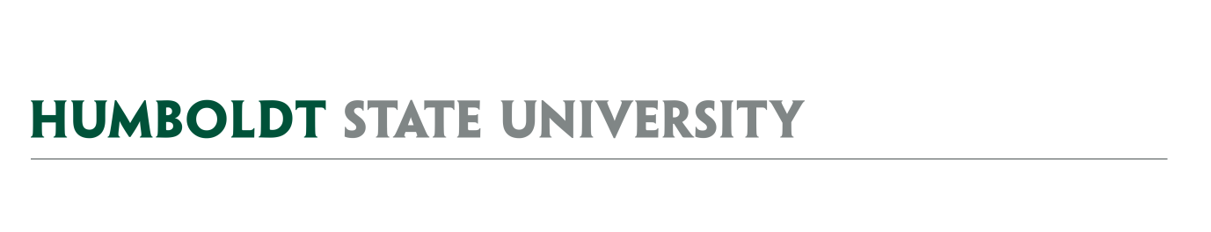
AGENDA
Facilities Management
University Space & Facilities Advisory Committee

MEETING LOCATION: SBS_405
MEETING TIME: 1:00-1:50 pm, Friday, September 13, 2019
LOCATION: SBS_405

- August 23 Meeting Notes

- Special Topic – Draft Campus Key & Access Control Policy

FUTURE AGENDA ITEMS
- Facilities Management Cost Recovery Policy

ATTACHMENTS & LINKS
- Minutes from 8/23/19 USFAC Meeting (docx – attached and link)
- Draft new HSU Key Policy (link) & 1996 HSU Key policy (link)

REMINDER – Next USFAC meeting is 9/27/19, 1:00-2:30pm, SBS_405.

