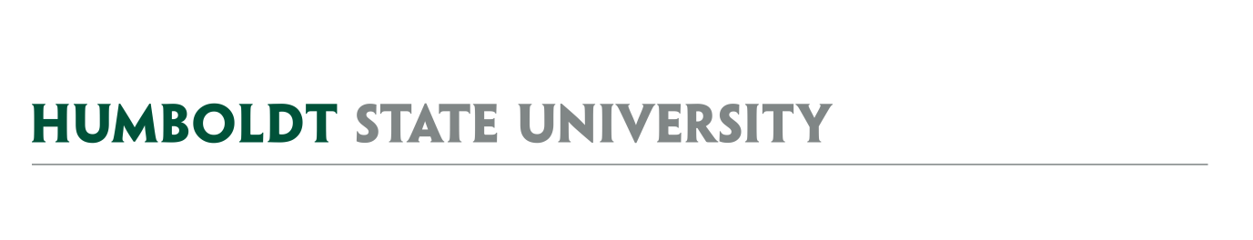
AGENDA
University Space & Advisory Committee
University Space & Facilities Advisory Committee

MEETING LOCATION: SBS_405
MEETING TIME: 2:30-4:00pm, Friday, Sept 27, 2019

- Meeting Notes
  - August 23, 2019 – Full meeting in FGYM_148, including Lactation Facility conversation
  - September 13, 2019 – Key Policy Focused Discussion

- AY1819 USFAC Details
  - Time and dates of AY1920 USFAC meetings – moving away from 1-2:30 Friday time.
  - Membership – Student members have been appointed by HSUAS. Welcome Caitlyn & Alia!

- USFAC Subcommittees
  - Landscape Working Group – nothing to report
  - Naming Committee – nothing to report
  - Facilities Use Subcommittee – attached notes from September 9 meeting – building liaisons.

- Campus Key Policy
  - Continue Key Policy discussion from September 13, 2019 (See links below)
  - Building Coordinator/Liaison update

- Space Management Issues
  - Vacated Space
    - Wagner House
    - Feuerwerker House
    - Library 109
    - SBDC Little Apartments
    - ACAC Gist
    - KHSU Theater Arts
    - Hilltop Marketplace
    - Budget Office SBS
    - Siemens Hall (SH_215A & 215B, 215)
    - TA 12
  - Summary of space moves
    - Office space in SBS to SPF on 4th floor
    - SBS_253 Shredder room to Lactation room by 8/5/19
    - Library Lactation Space & other Lactation Space proposal (Michael)
  - Space Requests via the webform – discuss campus “call”

FUTURE AGENDA ITEMS
- FM Cost Recovery Policy
- FM Project Process (informational)

ATTACHMENTS & LINKS
- Minutes from 8/23/19 USFAC Full Meeting (link)
- Minutes from 9/13/19 USFAC Key Policy Meeting (link)
- Draft new HSU Key Policy (link) & 1996 HSU Key policy (link)
- Lactation Station Proposal (link)

REMINDER- Next Focused USFAC meeting is planned for 10/11/19, ?? 2:30-3:30pm CCR ??, and the Next Full USFAC meeting is 10/25/19 ?? 2:30-4:00pm CCR ??

